Experiment 2: Host Discovery
Aim: To identify active hosts in a network using Nmap host discovery techniques.
Procedure:
- Open Kali Linux and launch the terminal.
- Select an authorized target host or local network.
- Execute nmap -sn 192.168.1.1 to perform host discovery without port scanning.
- Execute nmap -Pn 192.168.1.1 to skip host discovery and proceed with port scanning.
- Use nmap -PR 192.168.1.1 for ARP discovery on a local network.
- Use nmap -n 192.168.1.1 to disable DNS resolution.
- Observe the results and identify the hosts detected by Nmap.
Screenshots:
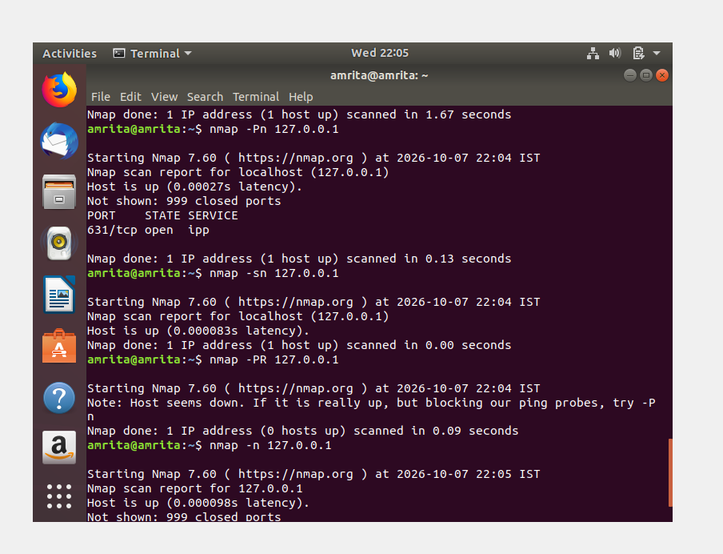
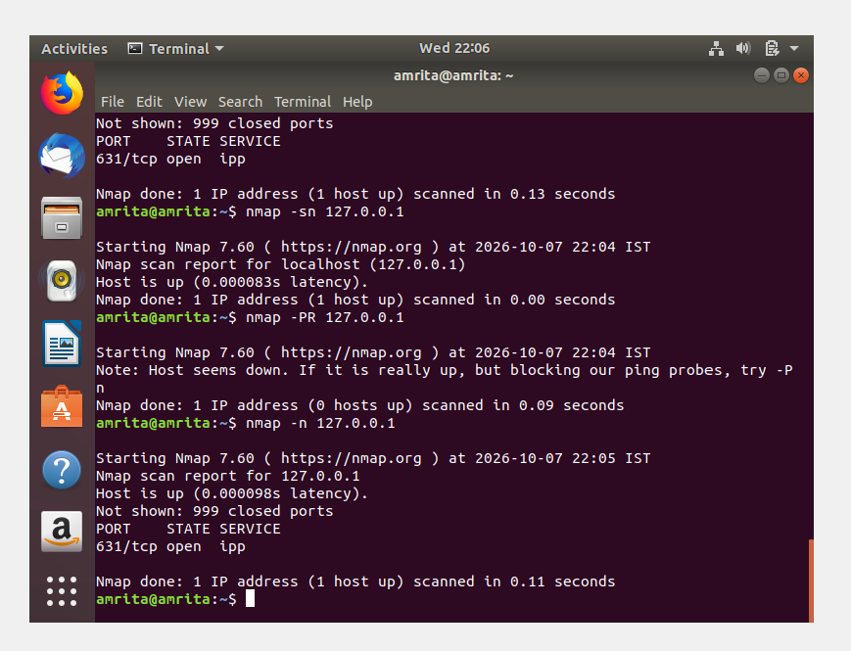

Result:
Thus, host discovery techniques were studied using Nmap, and the availability of hosts on the network was examined.

